# **OS Lab Assignment 1**

1. **Display Calender of year 2025 .**

**Ans:**

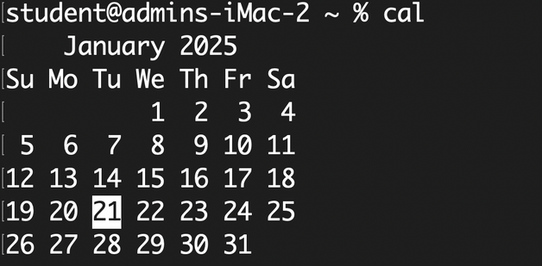

**2. Display the system’s date.**

**Ans:**

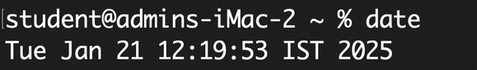

**3. Count the number of lines in the /etc/passwd file.**

**Ans:**

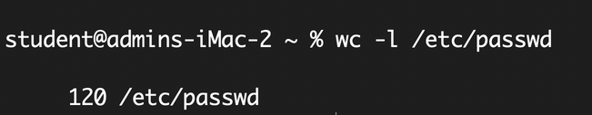

**4. Find out who else is on the system.**

**Ans:**

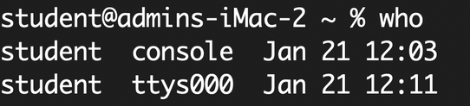

**5. Direct the output of the man pages for the date command to a file named mydate.**

**Ans:**

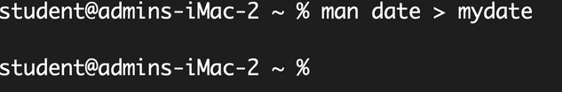

**6. Create a subdirectory called mydir.**

**Ans:**

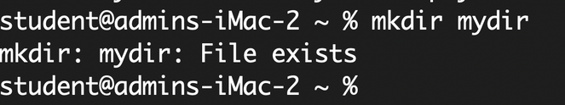

**7. Move the file mydate into the new subdirectory.**

**Ans:**

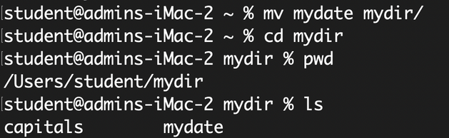

**8. Go to the subdirectory mydir and copy the file mydate to a new file called ourdate**

**Ans:**

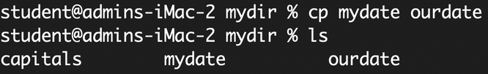

**9. List the contents of mydir.**

**Ans:**

2fc7a7a179028d02dc99e2a0470d4267.png

**10. Do a long listing on the file ourdate and note the permissions.**

**Ans:**

3d335041c9010abbb2ace2560a9c25fd.png

**11. Display the name of the current directory starting from the root.**

**Ans:**



**12. Move the files in the directory mydir back to your home directory.**

**Ans:**

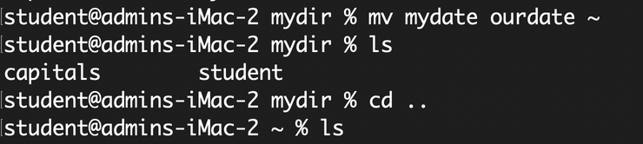

**13. Display the first 5 lines of mydate.**

**Ans:**

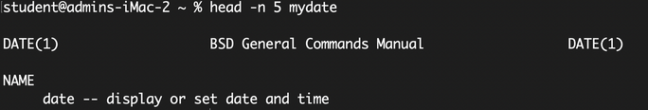

**14. Display the last 8 lines of mydate.**

**Ans:**

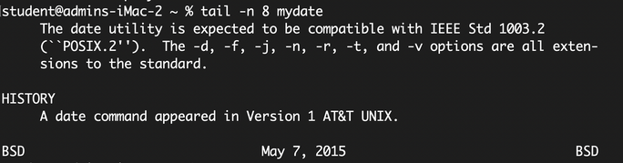

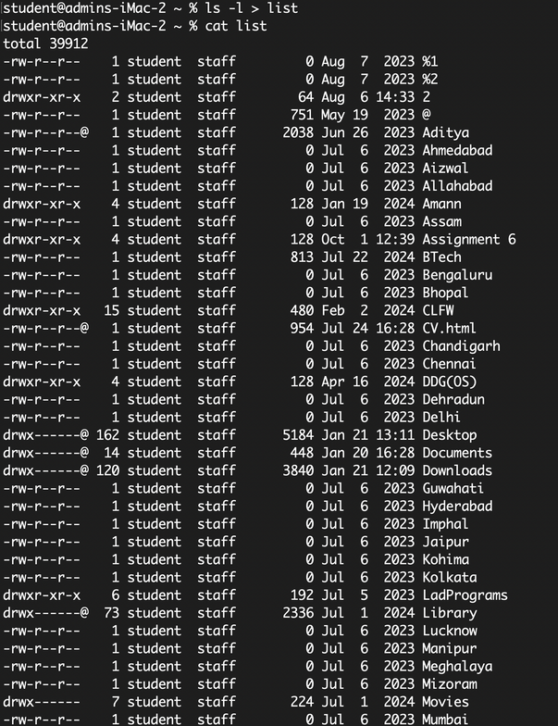

**15. Remove the directory mydir.**

**Ans:**

bceb0850f2f47e001fac3a3230de5b52.png

**16. Redirect the output of the long listing of files to a file named list.**

**Ans:**

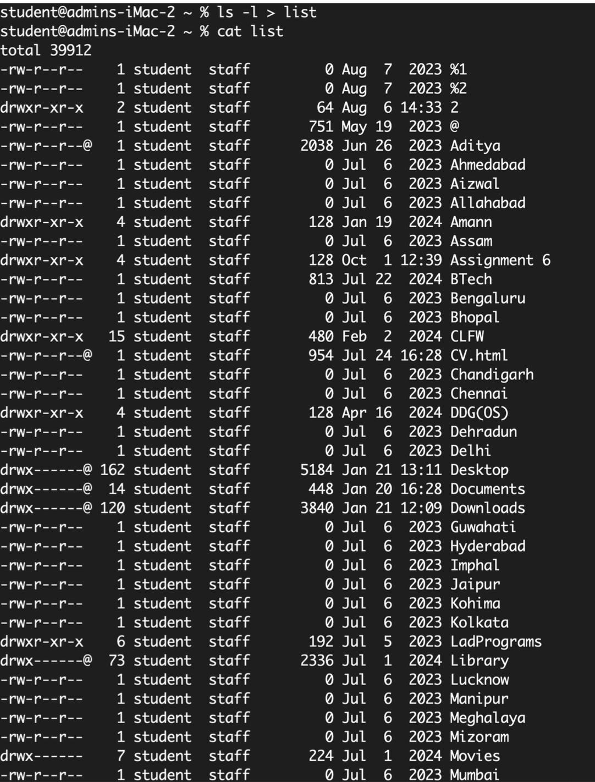

**17. Select any 5 capitals of states in India and enter them in a file named capitals1. Choose 5 more capitals and enter them in a file named capitals2. Choose 5 more capitals and enter them in a file named capitals3. Concatenate all 3 files and redirect the output to a file named capitals.**

**Ans:**

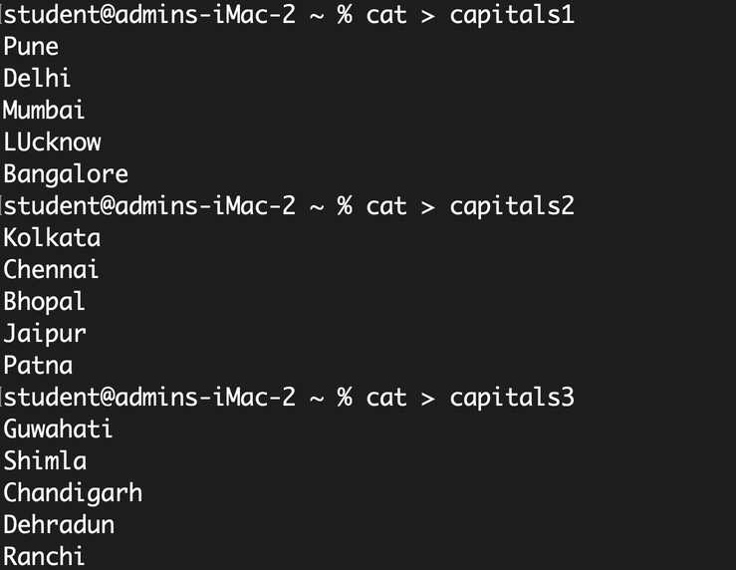

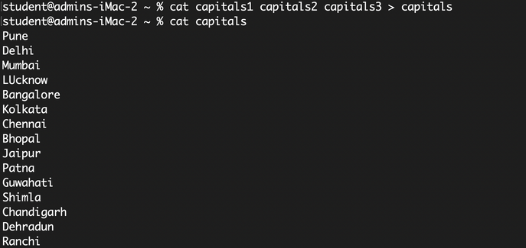

**18. Concatenate the file capitals2 at the end of file capitals.**

**Ans:**

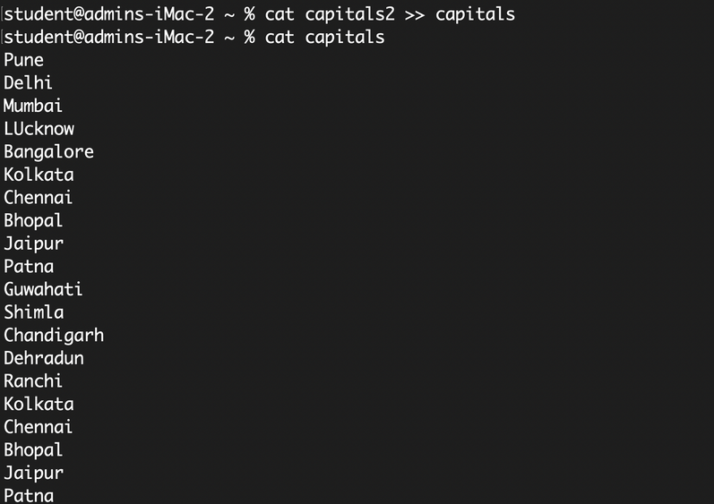

**19. Give read and write permissions to all users for the file capitals.**

**Ans:**

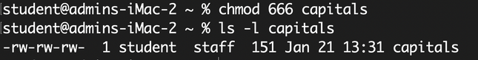

**20. Give read permissions only to the owner of the file capitals. Open the file, make some changes and try to save it. What happens ?**

**Ans:**

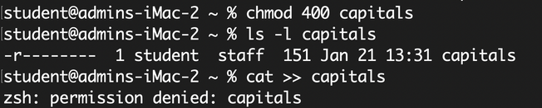

**21. Create an alias to concatenate the 3 files capitals1, capitals2, capitals3 and redirect the output to a file named capitals. Activate the alias and make it run.**

**Ans:**



**22. Find out the number of times the string “the” appears in the file mydate.**

**Ans:**

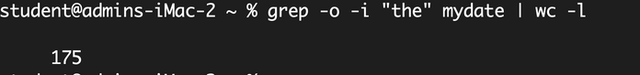

**23. Find out the line numbers on which the string “date” exists in mydate.**

**Ans:**

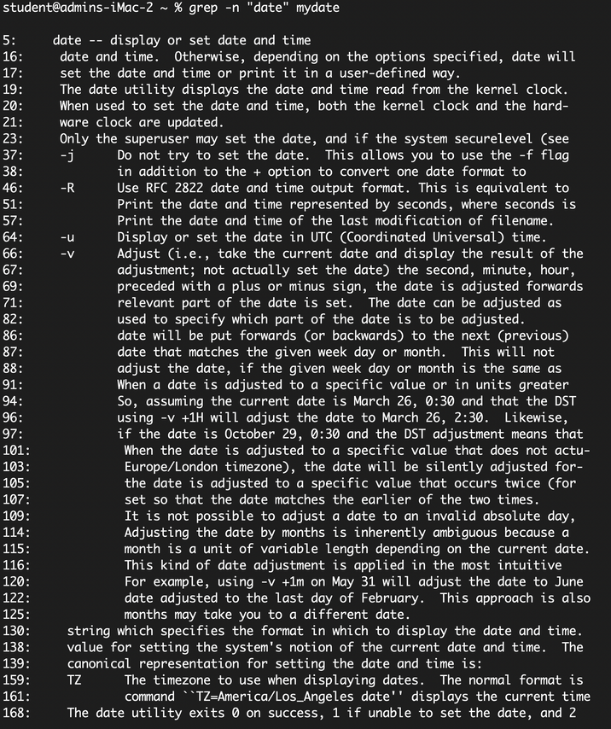

**24. Print all lines of mydate except those that have the letter “i” in them.**

**Ans:**

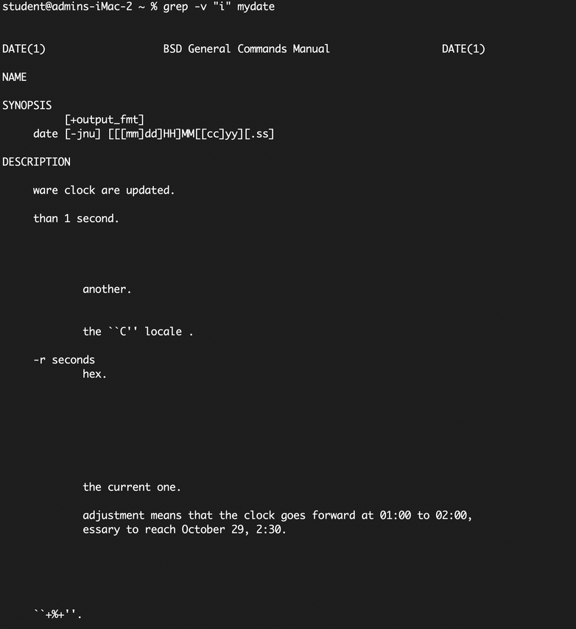

**25. List the words of 4 letters from the file mydate.**

**Ans:**

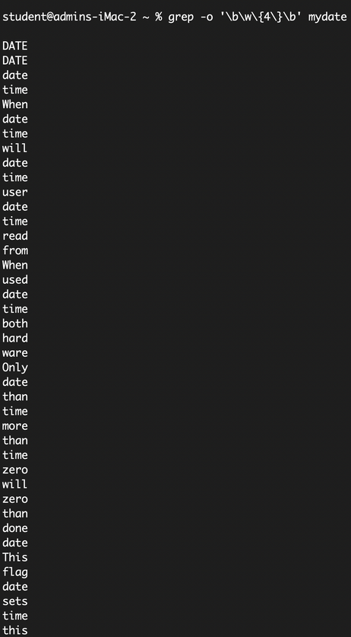

**26. List 5 states in north east India in a file mystates. List their corresponding capitals in a file mycapitals. Use the paste command to join the 2 files.**

**Ans:**

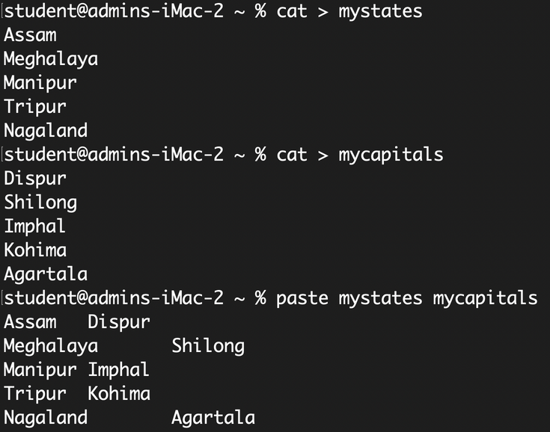

**27. Use the cut command to print the 1 st and 3 rd columns of the /etc/passwd file for all students in this class.**

**Ans:**

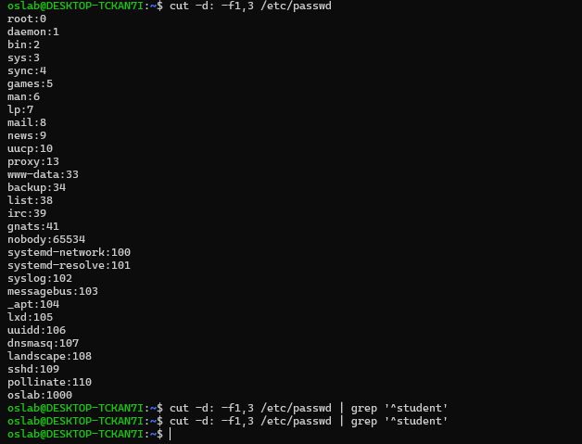

**28. Count the number of people logged in and also trap the users in a file using the tee command.**

**Ans:**

**student@admins-iMac-2 ~ % who | tee users.txt | wc -l**

**2**

**29. Convert the contents of mystates into uppercase.**

**Ans:**

**student@admins-iMac-2 ~ % tr 'a-z' 'A-Z' < mystates**

**ASSAM**

**MEGHALAYA**

**MANIPUR**

**TRIPURA**

**NAGALAND**

**30. Create any two files & display the common values between them.**

**Ans:**

**student@admins-iMac-2 ~ % cat > file1.txt**

**apple**

**banana**

**cherry**

**student@admins-iMac-2 ~ % cat > file2.txt**

**banana**

**cherry**

**date**

**student@admins-iMac-2 ~ % comm file1.txt file2.txt**

**apple**

**banana**

**cherry**

**date**

**student@admins-iMac-2 ~ %**